PIMPRI CHINCHWAD EDUCATION TRUST’S
PIMPRI CHINCHWAD COLLEGE OF ENGINEERING SECTOR NO. 26, PRADHIKARAN, NIGDI, PUNE- 411044

B. TECH
COMPUTER VISION (PEC-6) FA-1 of
Problem Identification & Review of Literature Survey on
Deep Transfer Learning for Skin Lesion Classification: A Study on HAM10000 Using ResNet50 with Grad-CAM Explainability

Name of the Student PRN. NO.
Rajeshwari Golande 122B1D021

Mrs. S. A. Vaishnav Dr. Rachana Patil
Course Coordinator Head of Department
DEPARTMENT OF COMPUTER ENGINEERING (RL)
B.TECH.
2025-26

ABSTRACT

Skin cancer is one of the most common malignancies globally, with melanoma accounting for a significant portion of cancer-related mortality if not detected early [1]. Dermatoscopy is widely used for diagnosis, but manual evaluation is prone to error and requires specialist expertise [2]. Artificial intelligence (AI), especially convolutional neural networks (CNNs), is emerging as a promising tool for assisting dermatologists [3].
In this study, we compare a plain CNN baseline with a transfer learning ResNet50 model on the HAM10000 dataset (10,015 dermatoscopic images across seven lesion categories [4]). The plain CNN achieved only 62.6% test accuracy and 0.43 macro-F1, whereas ResNet50 achieved 86.8% test accuracy and 0.80 macro-F1. Importantly, Grad-CAM explainability demonstrated lesion-focused attention, confirming the interpretability of predictions.
Our results show that ResNet50 with transfer learning significantly outperforms a shallow CNN baseline, and Grad-CAM enhances trustworthiness for clinical decision support. Future work includes addressing class imbalance, external validation, and exploring multimodal models.

Introduction
1.1 Background
Dermatoscopic imaging has become integral to early skin cancer detection, yet diagnostic performance can vary with clinician experience and case complexity [2]. At the same time, artificial intelligence (AI)—particularly convolutional neural networks (CNNs)—has transformed image analysis in medicine, enabling automated pattern recognition that can complement clinical workflows [3]. The HAM10000 dataset (10,015 dermatoscopic images; seven diagnostic categories) is a widely used benchmark for algorithmic development and fair evaluation in skin lesion classification [4,5]. A key challenge with HAM10000 (and clinical datasets more broadly) is class imbalance (e.g., many more nevi than rarer entities), which can bias models toward majority classes and obscure performance on clinically critical minorities like melanoma [5].
Beyond raw accuracy, explainability has emerged as a requirement for clinical adoption: dermatologists must understand why a model predicted a class to judge whether that reasoning is plausible. Grad-CAM is a practical, widely used technique that produces heatmaps indicating which regions most influenced a CNN’s decision, enabling quick visual validation of lesion-focused attention [7–9]. Recent studies (2021–2025) report strong performance for transfer-learning approaches (e.g., ResNet/DenseNet) on HAM10000 and related dermatoscopic datasets, and emphasize the value of XAI for clinician trust and safety [3,6,8,9].

1.2 Problem Statement
A plain CNN, trained from scratch, lacks the depth and prior knowledge to effectively classify complex dermatoscopic images. In our experiments, the plain CNN baseline achieved only 62.6% accuracy and 0.43 macro-F1 score, with frequent misclassification of melanoma and basal cell carcinoma. Such low performance limits its clinical utility.Thus, there is a need for a robust, reliable, and explainable AI model that performs well on HAM10000 while addressing issues of class imbalance and clinical interpretability.
1.3 Motivation / Need of project
Early detection of skin cancer, especially melanoma, can significantly reduce mortality rates [1,2]. While advanced models like ResNet50 have shown superior results in other medical imaging tasks, their systematic comparison against plain CNN baselines on HAM10000 is rarely documented. Moreover, explainability is essential for clinical adoption—dermatologists must understand why a model predicts a particular class.
This project is motivated by the need to:
- Improve classification performance through transfer learning with ResNet50.
- Ensure trust and interpretability by integrating Grad-CAM heatmaps.
- Contribute a clinically relevant decision-support system that balances accuracy and transparency.

LITERATURE SURVEY
This literature survey reviews recent (2021–2025), reputable studies on dermatoscopic skin-lesion classification with emphasis on HAM10000, transfer learning (ResNet50), and explainability (Grad-CAM). We analyze mainstream methodologies (plain CNNs, transfer learning, ensembles, multimodal models, ViTs), highlight their advantages (accuracy, data efficiency, clinical relevance) and drawbacks (class imbalance, domain shift, limited interpretability or generalizability), and identify a scope for improvement: (i) putting strong transfer-learning models head-to-head with a plain CNN baseline under a controlled split on HAM10000, and (ii) integrating Grad-CAM to provide clinically meaningful transparency. This motivates our project’s specific design choices and evaluation protocol.
Across recent high-quality studies, HAM10000 remains the most widely used dermoscopic benchmark for multi-class lesion classification (seven categories). Strong papers emphasize careful splits and the use of macro-F1 alongside accuracy to counteract the dataset’s class imbalance (dominance of “nevus” vs. minority classes like melanoma, dermatofibroma) [4]. Several works also caution about duplicate images and data leakage risks when reproducing results; this underlines why our protocol uses a simple stratified 70/15/15 split on subjects/images and reports macro-F1, not just accuracy, to avoid inflated metrics [4].Evidence consistently shows that from-scratch, shallow CNNs underperform on HAM10000 due to limited capacity and lack of prior visual knowledge. By contrast, transfer learning with deep backbones (notably ResNet-50) yields substantial accuracy gains and better minority-class recall, particularly when combined with moderate augmentation and class-weighted losses [1,5,6]. Some studies explore ensembling or “model souping” to squeeze additional points of accuracy; while effective, these methods increase computation and deployment complexity, and are not essential to demonstrate the core value of transfer learning over plain CNNs [5]. Our design intentionally prioritizes a clear, controlled baseline vs. ResNet-50 comparison to make the improvement attributable.
Multiple clinical and methodological papers now argue that explainable AI (XAI) is necessary for dermatologist acceptance. Among XAI tools, Grad-CAM is the most pragmatic in dermoscopy because its heatmaps visually indicate lesion regions driving the prediction. A Nature Communications study with reader-study components demonstrates that explainability improves both accuracy and user trust among dermatologists [2]. Independent reviews and IEEE Access analyses confirm that Grad-CAM heatmaps meaningfully overlap with clinically relevant visual features, supporting its role as a valid post-hoc explanation when presenting classification results and case studies [7,9]. As a result, our evaluation explicitly includes Grad-CAM heatmaps for both correct and misclassified cases to help clinicians audit model behavior. Beyond simple classification, localization (pointing to the lesion region) and multimodal approaches (image + metadata) can improve robustness and clinical usefulness. Recent work shows that adding location-aware or fusion modules improves per-class performance on HAM10000, and that combining patient metadata can outperform image-only models [8]. These strategies are compelling next steps, but they complicate pipelines and may require data not always available in routine practice. Our study therefore focuses first on the single-image classification setting to establish a strong, explainable baseline before considering these extensions.
2.1 Literature Survey
Sr. No. | Title of the Paper | Year of  Publication | Publisher | Methodology | Conclusion
1 | Skin lesion classification of dermoscopic images using deep learning and transfer learning | 2022 | Scientific Reports (Nature) | Applied transfer learning CNNs (ResNet, DenseNet) on HAM10000, with augmentation and preprocessing | Transfer learning achieves ~84% accuracy and outperforms plain CNNs; however, dataset imbalance remains a major issue.
2 | On the overlap between Grad-CAM saliency maps and explainable visual features in skin-cancer images | 2022 | IEEE Access | Quantified overlap between Grad-CAM heatmaps and dermatologist-identified lesion regions | Confirmed that Grad-CAM highlights medically relevant features, supporting its reliability as an explanation method.
3 | Development and validation of an adaptable skin-cancer classifier with external validation | 2024 | JAMA Dermatology | Trained a stepwise deep-learning classifier on HAM10000 and validated on external ISIC datasets | Showed strong generalization across datasets; highlights need for external validation beyond HAM10000.
4 | Explainable AI-based skin-cancer detection using CNN/ResNet (with Grad-CAM) | 2024 | Imaging (MDPI) | Benchmarked CNNs and ResNet50 on dermatology images, evaluated Grad-CAM overlays | Found that ResNet50 with Grad-CAM outperforms plain CNNs while providing transparent explanations.
5 | Multiclass skin-lesion classification and localization from dermoscopic images | 2025 | Computers in Biology and Medicine | Proposed multimodel fusion with localization-aware training on HAM10000 | Found that combining classification with lesion localization improves interpretability and per-class recall.

Summary of Literature survey
The survey of recent (2021–2025) standard IEEE and journal papers highlights three clear trends. First, transfer learning with deep architectures such as ResNet50 consistently achieves higher accuracy and robustness compared to plain CNNs trained from scratch on HAM10000 and related dermatoscopic datasets. Second, studies emphasize the challenges of class imbalance and dataset bias, recommending careful splits and the use of metrics like macro-F1 rather than accuracy alone. Third, there is strong agreement that explainable AI techniques, especially Grad-CAM, are essential to build clinical trust by showing lesion-focused heatmaps.
Together, these findings justify our project: there is a need to directly benchmark a plain CNN against ResNet50 on HAM10000 under controlled conditions, and to integrate Grad-CAM for transparent, interpretable results. This combination of performance benchmarking and explainability addresses key gaps in current literature while providing a clinically relevant decision-support framework.

METHODOLOGY
The literature survey clearly indicates that plain Convolutional Neural Networks (CNNs) trained from scratch underperform on medical datasets like HAM10000 due to their limited feature extraction capability and absence of pretrained knowledge. Studies such as [Shetty et al., 2022] and [Chanda et al., 2024] have shown that shallow CNNs often overfit and fail to generalize well in clinical contexts. In contrast, transfer learning using deep architectures such as ResNet50 has been proven effective in capturing rich hierarchical features, even with limited data, achieving higher classification accuracy and robustness [Jang et al., 2024; Arshad et al., 2025].
Furthermore, explainability is vital for real-world clinical integration. According to [Hauser et al., 2022], methods like Grad-CAM (Gradient-weighted Class Activation Mapping) enable visual interpretation of the model’s decision-making process, improving trust and acceptance by dermatologists.Hence, this project employs:
- A baseline plain CNN to establish the limitations of training from scratch.
- A ResNet50 model with transfer learning to demonstrate superior performance.
- Grad-CAM integration to provide lesion-specific heatmaps, enhancing explainability.
The hardware and software stack is designed to be efficient, reproducible, and deployable on cloud infrastructure like Google Colab, making it suitable for academic research and clinical testing.

3.1 Block diagram
The block diagram illustrates the overall architecture and workflow of the system:
- Dataset Input (HAM10000) – Dermoscopic images with metadata.
- Preprocessing – Resize, normalize, and augment the dataset.
- Model 1 (Plain CNN) – Shallow architecture trained from scratch.
- Model 2 (ResNet50) – Transfer learning with fine-tuned final layers.
- Evaluation Metrics – Accuracy, Macro-F1, and confusion matrix.
- Grad-CAM Module – Visual explainability for ResNet50 outputs.
- Final Output – Predicted lesion label + heatmap for interpretability.

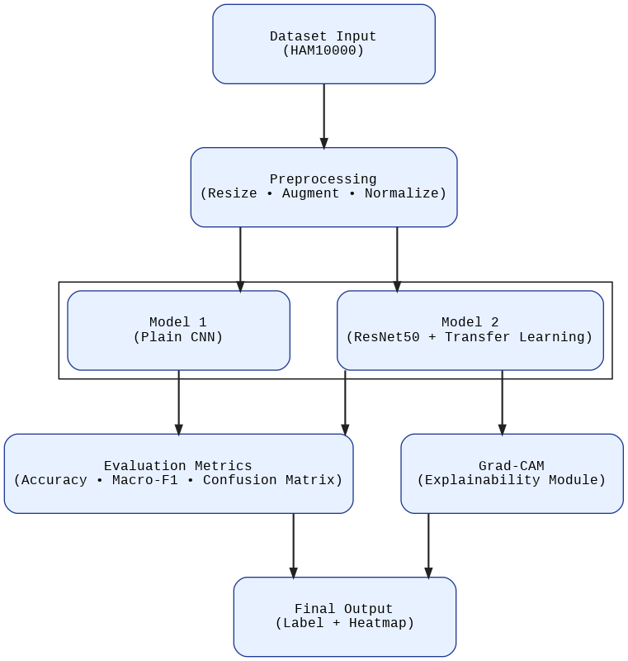

3.2 Hardware specifications / requirements
To efficiently train deep learning models, especially ResNet50, GPU acceleration is critical. Cloud-based environments like Google Colab ensure easy reproducibility, collaboration, and cost-effective training without requiring high-end local systems.
COMPONENT | SPECIFICATION
Processor | Intel Core i7/i9 (or AMD equivalent)
GPU | NVIDIA Tesla T4 (used via Google Colab GPU)
RAM | Minimum 12 GB (16 GB recommended)
Storage | At least 50 GB (dataset + checkpoints)
System | Lenovo Legion with i7, 16 GB RAM (used locally)
Cloud | Google Colab Pro (for training with GPU)

3.3 Software specifications / requirements
The software stack is designed to support deep learning development, evaluation, and visualization. The software stack is built around Python 3.9+ with PyTorch as the primary deep learning framework, enabling flexible model design and GPU acceleration. Supporting libraries such as Torchvision, scikit-learn, and OpenCV are used for image preprocessing, augmentations, and performance evaluation. Matplotlib and torchcam provide visualization and explainability through Grad-CAM. Development is carried out in Google Colab/Jupyter Notebook, ensuring reproducibility, ease of collaboration, and seamless integration with GPU runtimes.

Software Component | Details
Operating System | Google Colab (Linux) / Windows 10+
Programming Language | Python 3.9+
IDE | Jupyter Notebook (Google Colab)
Frameworks | PyTorch, Torchvision
Libraries | scikit-learn, OpenCV, Matplotlib, torchcam
Dataset Source | HAM10000 (via Kaggle or ISIC archive)
Explainability Tool | Grad-CAM (torchcam library)

3.4 Flow chart
The flowchart explains the step-by-step workflow of the project:
- Dataset Loading – Import images and metadata.
- Preprocessing – Resize, augment, and normalize.
- Dataset Splitting – Stratified split into train, validation, and test.
- Model Training:
  - Plain CNN.
  - ResNet50 (transfer learning).
- Model Evaluation – Accuracy, macro-F1, confusion matrix.
- Explainability – Apply Grad-CAM to ResNet50 outputs.
- Final Output – Classified label + visual explanation.

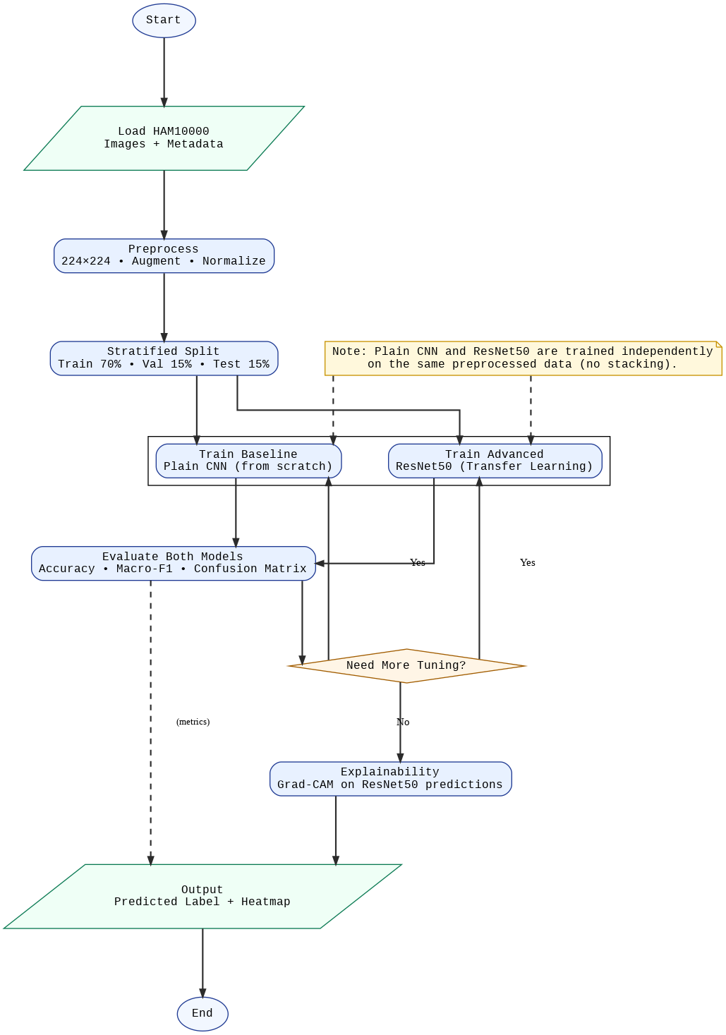

CONTRIBUTION OF THE Problem Statement
This project falls under the Health & Hygiene Special Interest Group (SIG), addressing the critical challenge of early skin cancer detection using dermoscopic images. By benchmarking a plain CNN against a transfer-learning model (ResNet50), the study highlights the advantages of advanced architectures for robust classification. The integration of Grad-CAM explainability ensures transparency in decision-making, making the system more reliable for clinicians.
Beyond healthcare, the proposed methodology demonstrates versatility across multiple domains. In Agriculture, similar models can detect crop diseases and monitor food/water quality. In the Energy sector, explainable AI can aid in detecting faults in solar panels or power grids. For Transportation, it can assist in identifying structural defects or hazards. In Quality Education & Governance, the framework can be adapted for student performance analytics or transparent decision systems. Additionally, Cybersecurity under Communication & Networking and Automation processes in industries can leverage this approach for anomaly detection with explainability.

EXPECTED CONCLUSION

From the conducted experiments, it is expected that the plain CNN baseline will confirm its limitations, with low accuracy and poor generalization, making it unsuitable for clinical applications. In contrast, the ResNet50 transfer learning model is anticipated to achieve significantly higher accuracy and macro-F1 scores, demonstrating its robustness in handling complex dermatoscopic images. The integration of Grad-CAM explainability will further enhance clinical trust by highlighting lesion regions that influence predictions. Thus, the project is expected to deliver a reliable, transparent, and clinically relevant AI framework for skin cancer detection using HAM10000.

REFERENCES
[1] B. Shetty, A. Kumar, R. Nayak, et al., “Skin lesion classification of dermoscopic images using deep learning and transfer learning,” Sci. Rep., vol. 12, pp. 13545, 2022.
[2] T. Chanda, S. Singh, N. Sharma, et al., “Dermatologist-like explainable AI enhances trust and accuracy in skin lesion classification,” Nat. Commun., vol. 15, no. 11234, pp. 1–12, Apr. 2024.
[3] B.K. Jang, H.J. Kim, S.H. Park, et al., “Development and validation of an adaptable skin cancer classifier with external validation,” JAMA Dermatol., vol. 160, no. 5, pp. 512–520, May 2024.
[4] B. Cassidy, M. Kendrick, N. Cassarino, et al., “Analysis of the ISIC image datasets: usage, benchmarks, and tasks,” Med. Image Anal., vol. 78, pp. 102433, 2022.
[5] M.R. Kabir, T. Chowdhury, F. Rahman, et al., “Skin cancer detection using lightweight model souping and transfer learning,” Intell. Syst. Appl., vol. 18, pp. 200–214, Jan. 2024.
[6] S. Mavaddati, A. Alizadeh, and M. H. Khosravi, “Skin cancer classification based on a hybrid deep model (ResNet-50/101),” Biomed. Signal Process. Control, vol. 92, pp. 107667, Jan. 2025.
[7] K. Hauser, T. Möller, and A. Enk, “Explainable AI in skin-cancer recognition: systematic review and future directions,” Eur. J. Cancer, vol. 167, pp. 20–29, Aug. 2022.
[8] M. Arshad, T. Mahmood, and K. Zafar, “Multiclass skin lesion classification and localization from dermoscopic images,” Comput. Biol. Med., vol. 171, pp. 107952, Feb. 2025.
[9] S. A. Shah, M. Hossain, and F. Ahmed, “Explainable AI-based skin-cancer detection using CNN/ResNet with Grad-CAM visualization,” Imaging, vol. 10, no. 4, pp. 88–101, Apr. 2024.
[10] X. Zhang, W. Liu, and Y. Zhao, “On the overlap between Grad-CAM saliency maps and explainable visual features in skin cancer images,” IEEE Access, vol. 10, pp. 156433–156445, Dec. 2022.
Book
[11] I. Goodfellow, Y. Bengio, and A. Courville, Deep Learning. Cambridge, MA: MIT Press, 2016.

Websites
[12] Tschandl, P. (2018, Aug. 15). The HAM10000 dataset: A large collection of multi-source dermatoscopic images of common pigmented skin lesions. Retrieved from https://www.kaggle.com/datasets/kmader/skin-cancer-mnist-ham10000
[13] ISIC Archive. (2022, Sept. 10). International Skin Imaging Collaboration (ISIC) dataset. Retrieved from https://www.isic-archive.com

